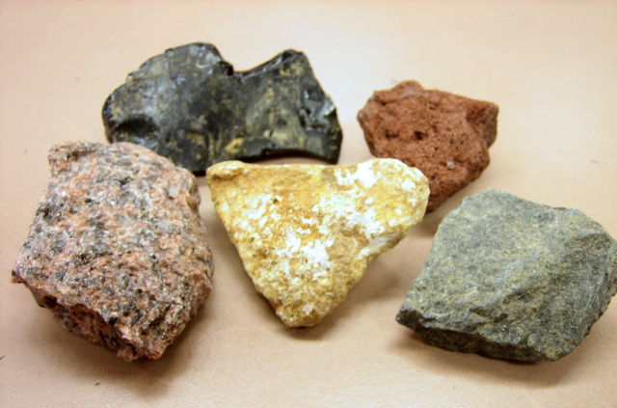

Igneous rocks are formed when molten rock (magma) cools and solidifies either below (intrusive) or above (extrusive) the Earth’s surface. The rate at which the magma cools determines the rock’s properties. An igneous rock can take minutes or millions of years to form, depending on its rate of solidification and cooling of magma. Magma itself takes millions of years to be created as tectonic plates slide under each other and melt.

Intrusive igneous rocks such as diorite, gabbro and granite have coarse grains. They have larger crystals than extrusive rocks because of a slower cooling and solidification rate below the surface.

Extrusive igneous rocks such as basalt, obsidian and pumice have much smaller crystal formations than intrusive igneous rocks because of the faster cooling rates that occur on the surface.

Give the meaning of the following words in the paragraphs above:

1. Molten _______________________________________________________________

2. Solidifies _____________________________________________________________

3. Intrusive ______________________________________________________________

4. Extrusive _____________________________________________________________

5. Properties _____________________________________________________________

6. Magma _______________________________________________________________

7. Coarse _______________________________________________________________

Which words or phrases can be replaced with the following:

1. Made ________________________________________________________________

2. Goes hard ____________________________________________________________

3. Speed ________________________________________________________________
4. Characteristics _________________________________________________________

5. Produced _____________________________________________________________

6. Rough _______________________________________________________________

7. Happen _______________________________________________________________
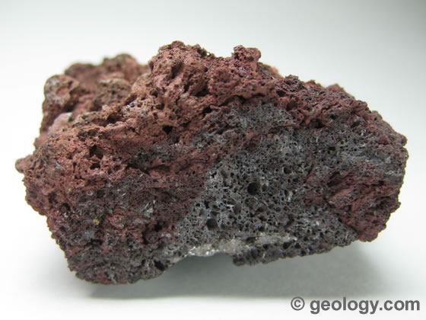

Questions

1. How are igneous rocks formed? ________________________________________

__________________________________________________________________

2. What determines a rock’s properties? ____________________________________

__________________________________________________________________

3. How long does an igneous rock take to form? _____________________________

__________________________________________________________________

4. How long does magma take to form? ____________________________________

__________________________________________________________________

5. Name two intrusive igneous rocks ______________________________________

6. How are intrusive igneous rocks different to extrusive igneous rocks? __________

__________________________________________________________________

__________________________________________________________________

7. Name two extrusive igneous rocks ______________________________________

8. Why do extrusive igneous rocks have small crystals? _______________________

__________________________________________________________________


